**Ideation Phase**

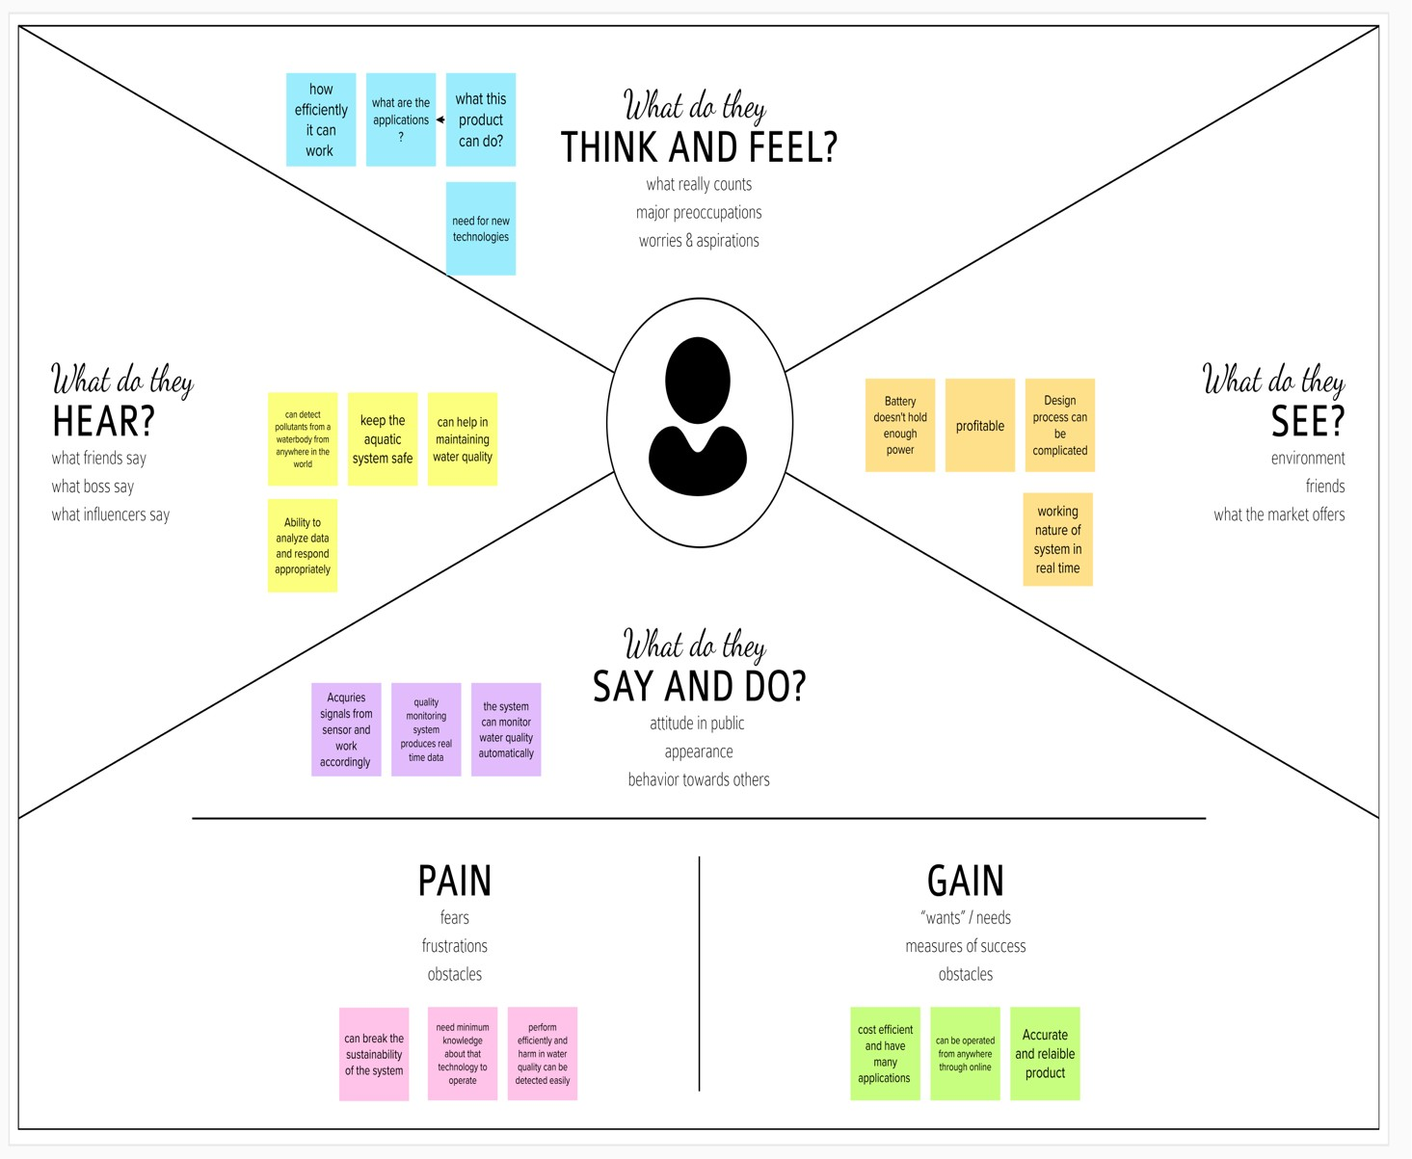

Empathy map

Empathize and Discover

|  |  |
| --- | --- |
| Date | 19 September 2022 |
| Team ID | PNT2022TMID41871 |
| Project Name | Project – Real time river water quality monitoring and control system |
| Maximum Marks | 4 Marks |